<https://www.selenium.dev/documentation/>

Automated Testing Mentoring: Advanced

QA

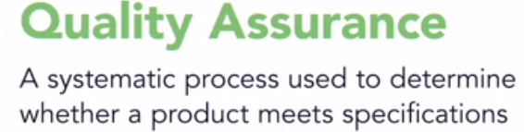

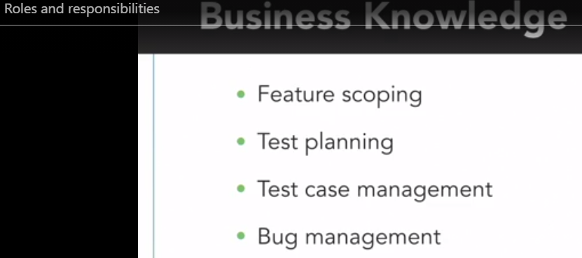

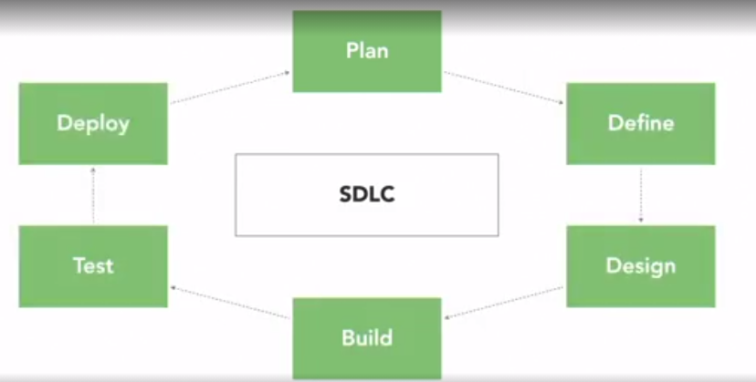

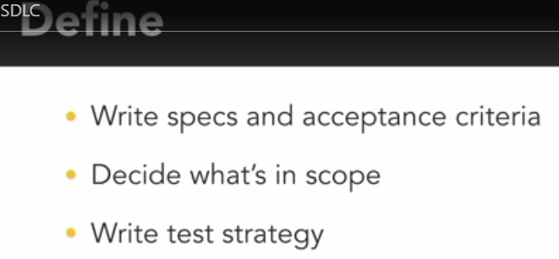

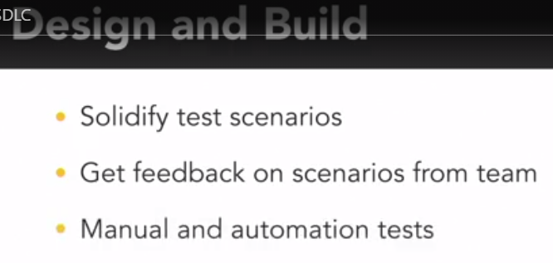

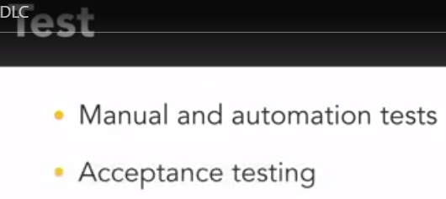

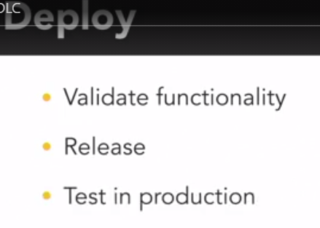

Test strategy – how the product will be tested

Test Plan

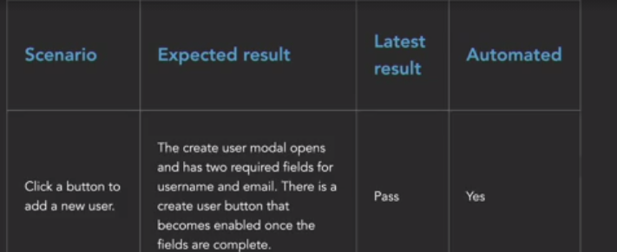

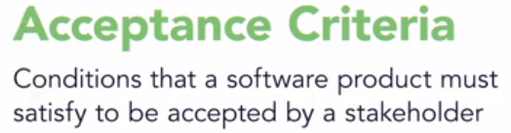

Given – When – Then (And)

Testing types

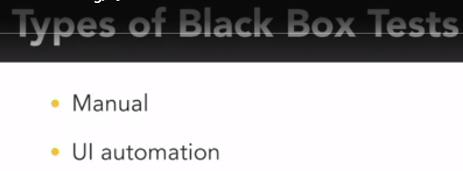

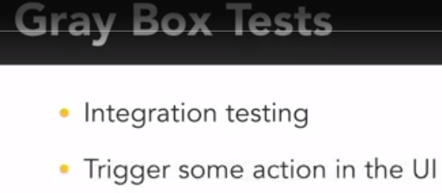

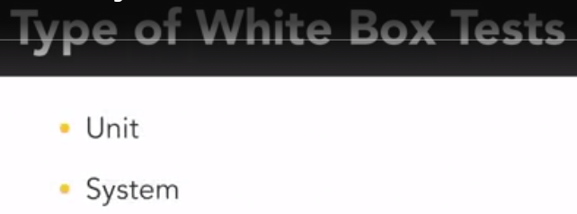

Bugs



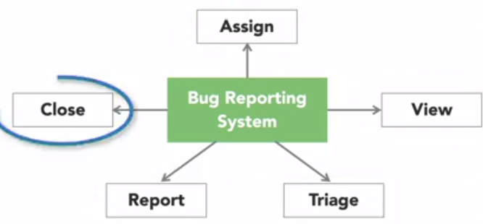

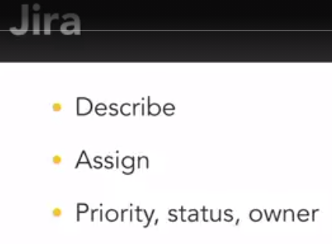

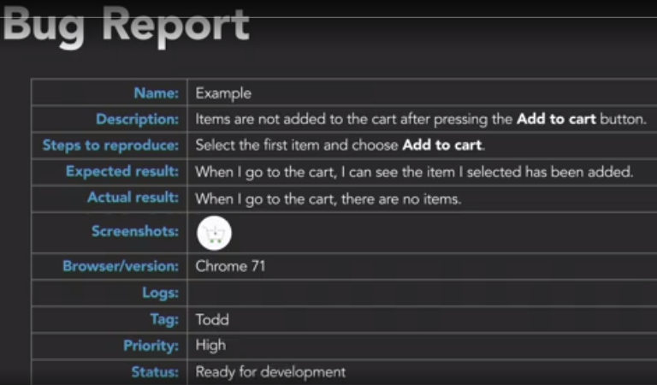

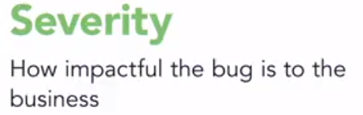

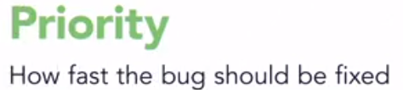

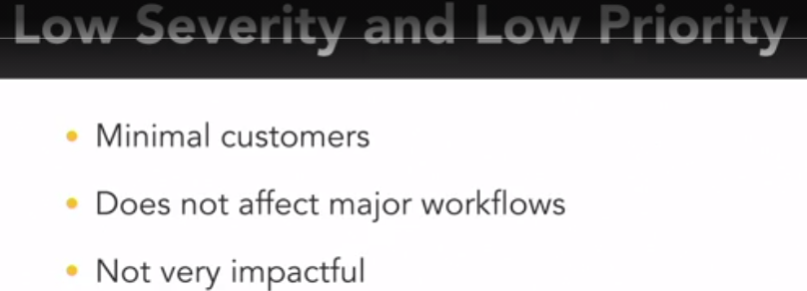

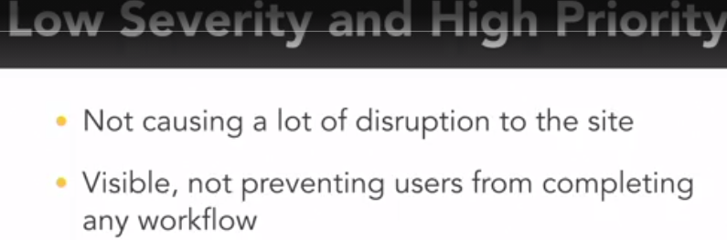



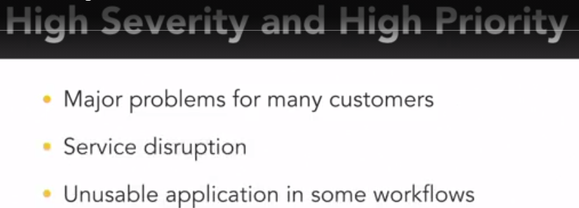

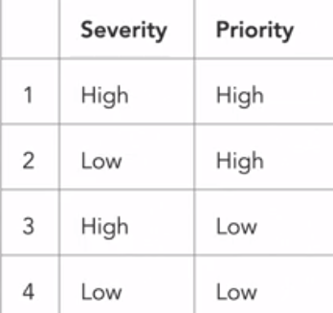

Mob testing – all teams sessions for finding bugs by explore app 2-4 times per year

Agile testing is an interactive, self-organizing process, where experience and collaboration govern the ability to deliver effectively, taking the nature of agile and matching it with the best integration points within a workflow to provide the most feedback possible, all the while accessing most knowledge and understanding about technology at the very state it is in. Imagine that, not waiting until the end; but instead, meeting the development process with innovative and planned integration of testing along the way, no longer leaving questions around quality as an afterthought. Instead, evolving the development process to include governed quality checks in each stage where decisions are being made. Working in this way has the



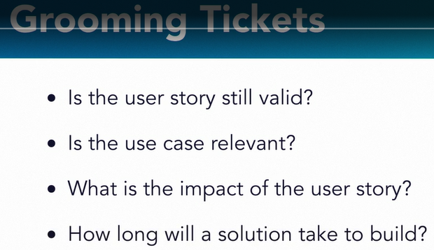

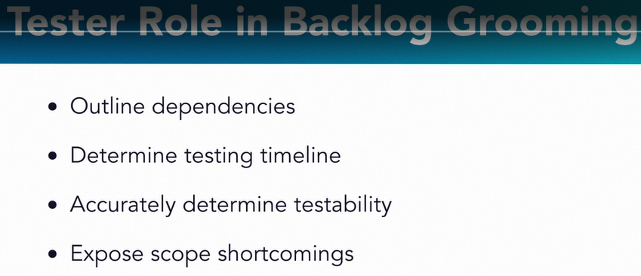

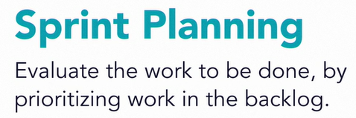

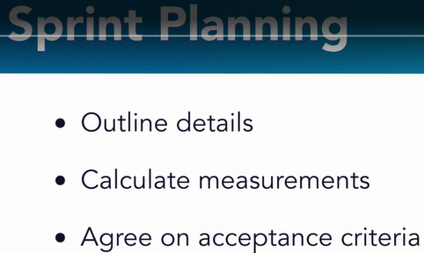



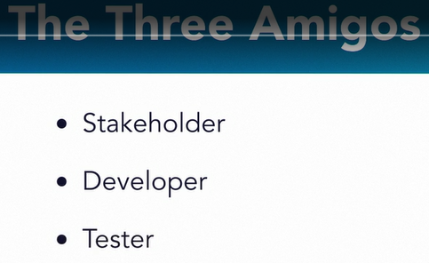



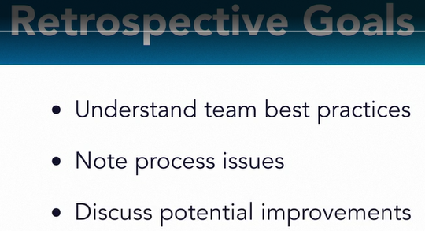





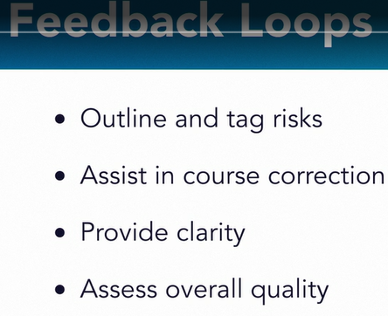



Client devices users platform technologies in use

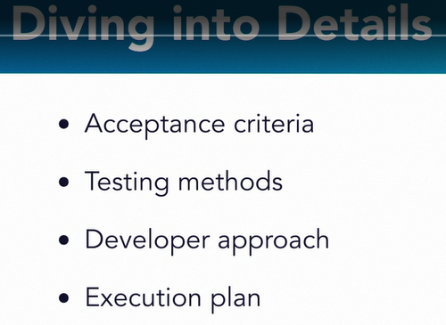



Feedback loop — это сбор фидбека пользователей на масштабе, без привлечения UX или Research-специалистов. Это помогает понять не то, где проблема (для этого есть количественная аналитика), а узнать, почему она возникает и как ее можно решить.

**Что спрашивать?**

Несмотря на то что все продукты разные, базовые вопросы у всех плюс-минус одинаковые. Для себя я выбрал такой набор:

* Почему пользователь решил зарегистрироваться?
* Почему он воспользовался фичей Х?
* Почему он не воспользовался фичей Х сколько-то раз? Тут объясню. Если вы даете пользователю 10 бесплатных кредитов, а он почему-то не использовал их все — стоит узнать почему.
* Почему пользователь заплатил?
* Что остановила пользователя от оплаты?
* Почему пользователь платит нам уже 3-6-12 месяцев?

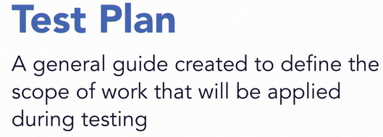

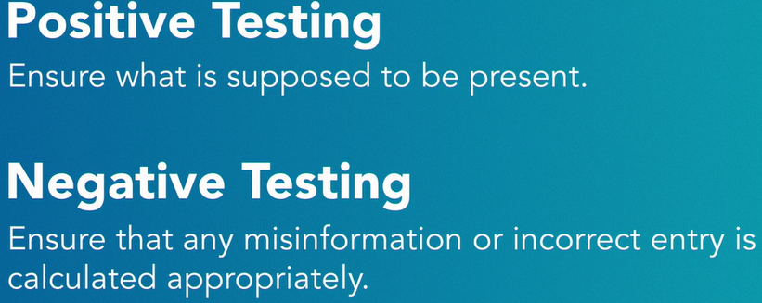

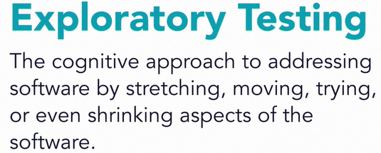



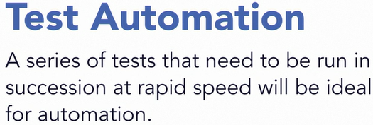





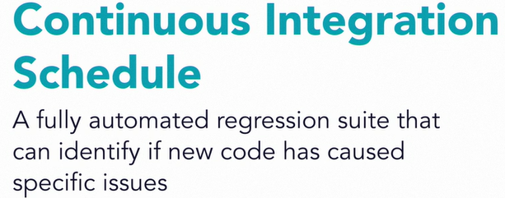

Automation

Value of Automation Testing – speed up repeatable, plain and easy verification steps in manual testing. Goes OK if app is stable.

What to automate

* Most valuable features with high priority
* Boring for manual flows
* Stable flows that gives same result every time

Goal – end-to-end functional UI testing. Smoke, regression.

Test Pyramid

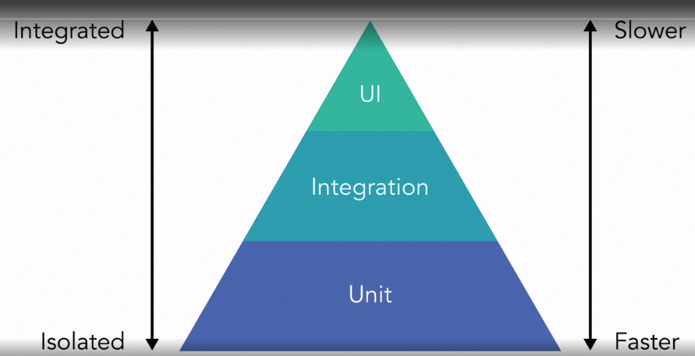

Testing quadrants

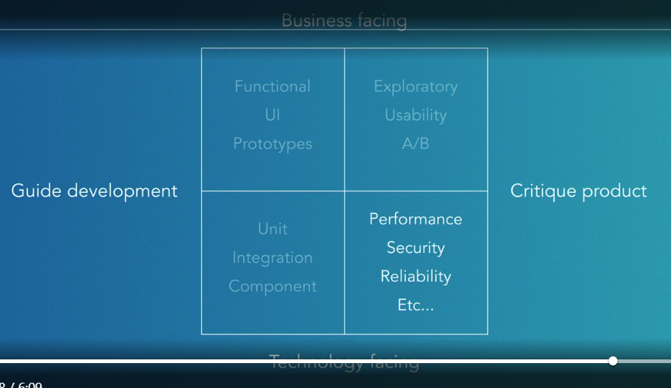

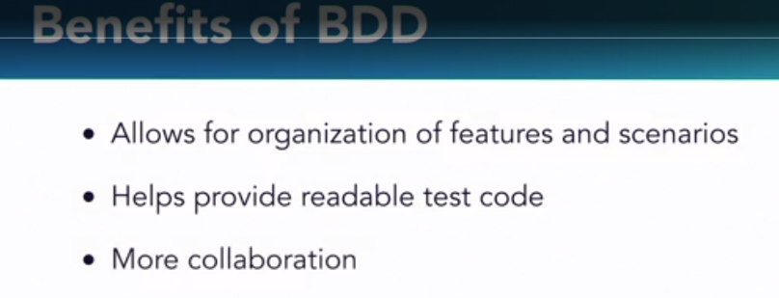

How to add priority for test cases to be automated

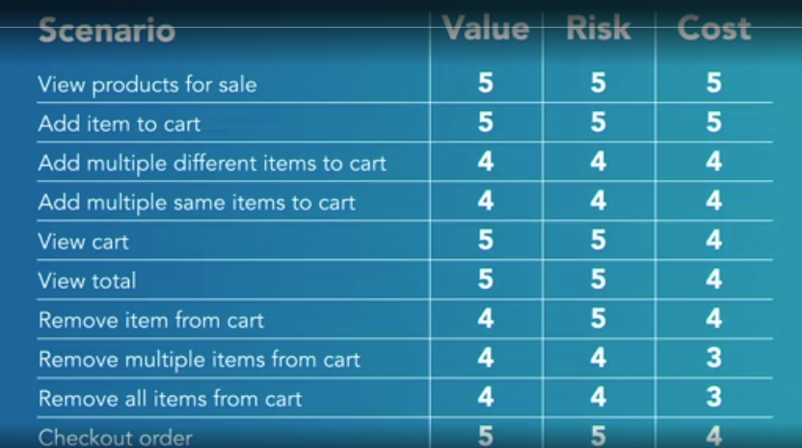

Value – how often feature will be used by users and is needed by business.

Risk – how long and expensive will cost feature if it will become broken.

Cost – time to write a test.

Rules of healthy test suite

* Valuable test –always check its value by retrospective, quality over quantity, write it as it will go to production.
* Reliable – every time same result, independent (do not make changes for other test cases), use dedicated envs (QA env)
* Fast – less UI tests, parallel run

Maintenance Moments

* Adding tests – continuously adding of new tests, talk together how to test new features.
* Updating tests – outdate test cases need to be updated, not relevant removed, some test data can be updated
* Fixing failures – tests fail sometimes, they should pass if no bugs are indicated. What to do – isolate flaky and rerun to identify problem, resolve than add again to main suite.

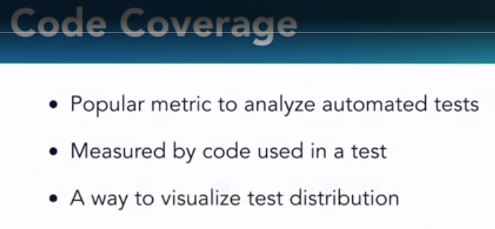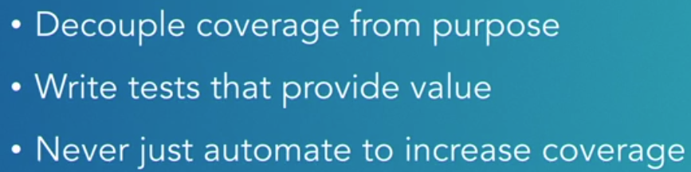

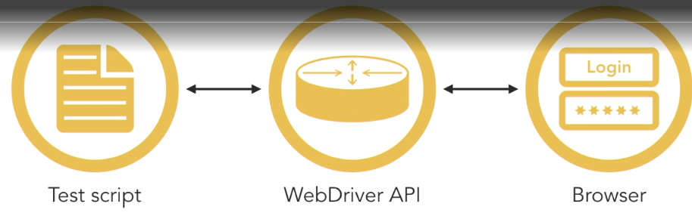

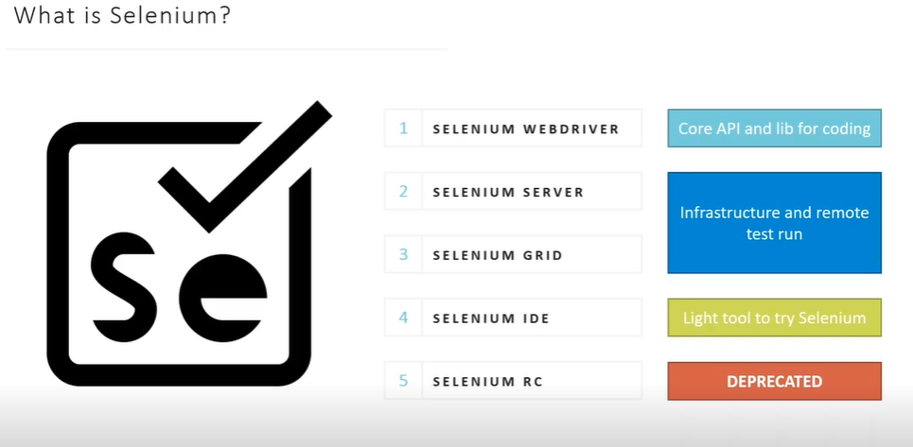

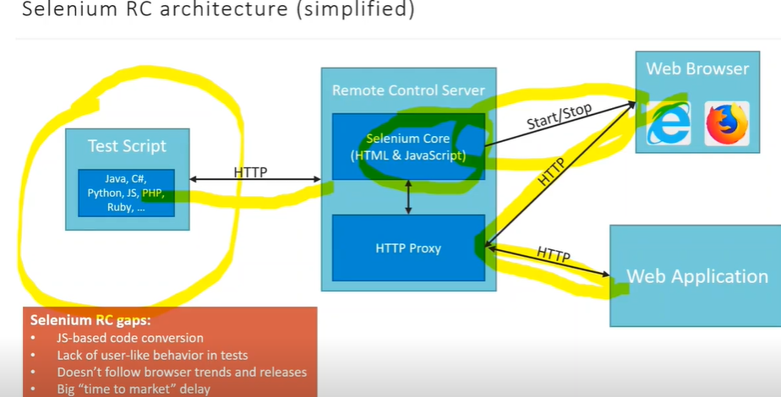

For Remote: Selenium Server send then instructions to the nodes where node’s webdriver receive instructions and send them to browser( Selenium Grid)

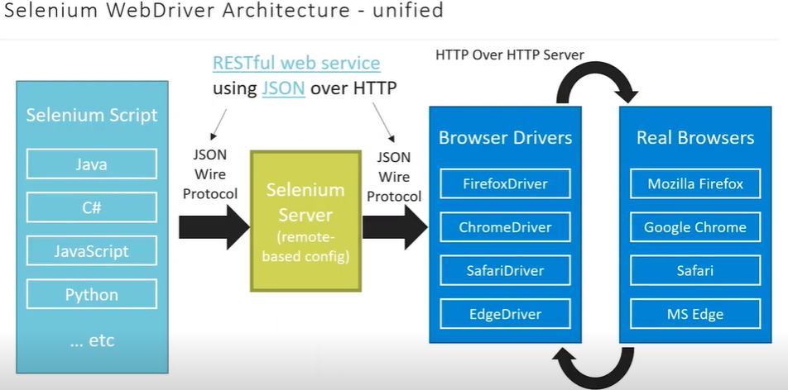

For Local, when you run your test cases on same machine, so instructions (scripts and browser on same machine) – Selenium WebDriver

